**Before you install**

Before installing be aware of the following issues:

* Leap Motion software needs up to 400MB of free disk space to install.
* Update the latest graphics drivers for your computer before installing Leap Motion software.
* Use Internet Explorer 10 or higher, or another browser to download Leap Motion software.
* If you have problems downloading the software, temporarily disable any anti-virus software that is running.

**Begin installation**

Follow these steps to install Leap Motion software on your computer.

1. Connect your keyboard or sensor to a USB 2.0 port on your computer.
2. In your Internet browser, go to [https://www.leapmotion.com/setup](http://h10025.www1.hp.com/ewfrf/wc/leavinghp?url=https%3A%2F%2Fwww.leapmotion.com%2Fsetup&desc=https%3A%2F%2Fwww.leapmotion.com%2Fsetup&lc=pt&cc=pt) (in English)
3. Click **Windows Download** to begin downloading Leap Motion software.
4. **Figure 1: Download Leap Motion for Windows**

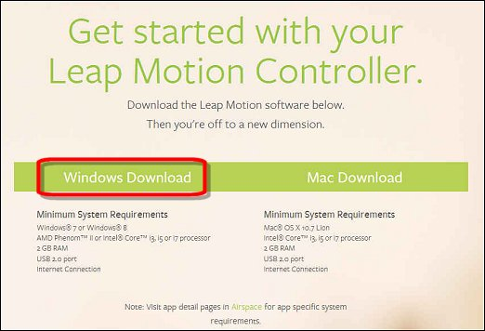

1. The **Welcome to Leap Motion** window opens. Follow the setup manager directions to install Leap Motion.

**Figure 2: Setup Welcome window**

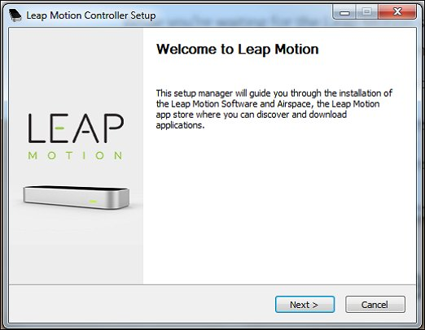

**Figure 3: Installation Complete window**

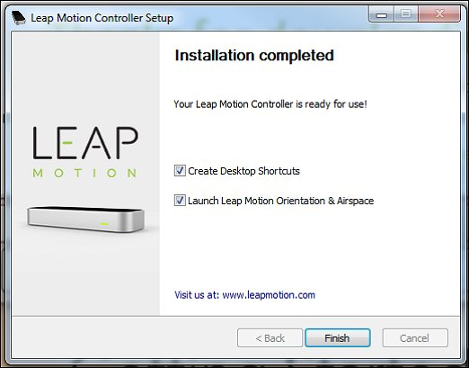

1. After installation is complete, you are prompted to restart your computer. Click **Restart Now**.

**Figure 4: Restart Now**

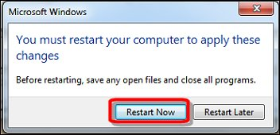

## Setting up Leap Motion

You must have a Leap Motion sensor to set up and use Leap Motion.

**Figure 5: Leap Motion sensor**

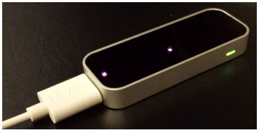

Follow these steps to set up your Leap Motion device.

1. Connect your computer to the Internet.
2. Open Leap Motion Airspace.

|  |  |
| --- | --- |
| **In Windows 8** | **In Windows 7** |
| At the Start screen, type leap to open the Search charm. Select **Leap Motion Airspace** in the Search results. | Click on the Airspace icon on the Desktop. |
| **Figure 6: Leap Motion Airspace**  Leap Motion Airspace on the  Windows 8 Search screen | **Figure 7: Airspace icon**  Airspace icon on the Windows 7 desktop |

1. If you have not already activated the Leap Motion sensor, the computer prompts you to activate the sensor by pressing fn and spacebar. When the sensor is activated, you see two red LEDs inside the Leap Motion sensor turn on. A small white or green light next to the Leap Motion sensor also turns on.

**Figure 8: Activate the Leap Motion sensor**

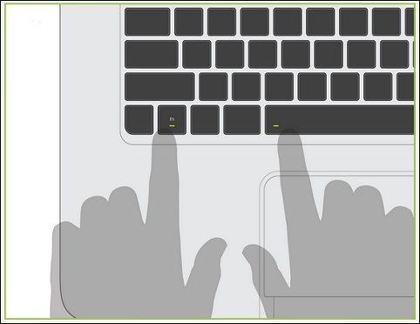

1. Get started by signing up for a Leap Motion account or sign in to an existing account.

**Figure 9: Get Started screen**

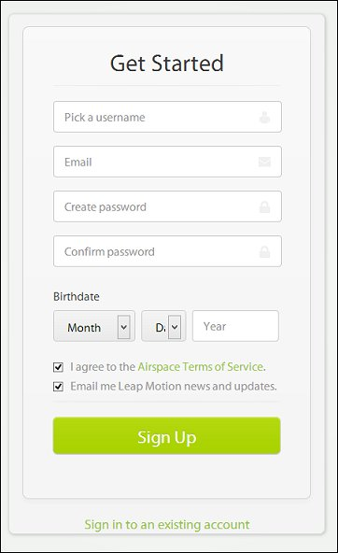

1. Open the Leap Motion Visualizer App.

**Figure 9: Test hands tracking**

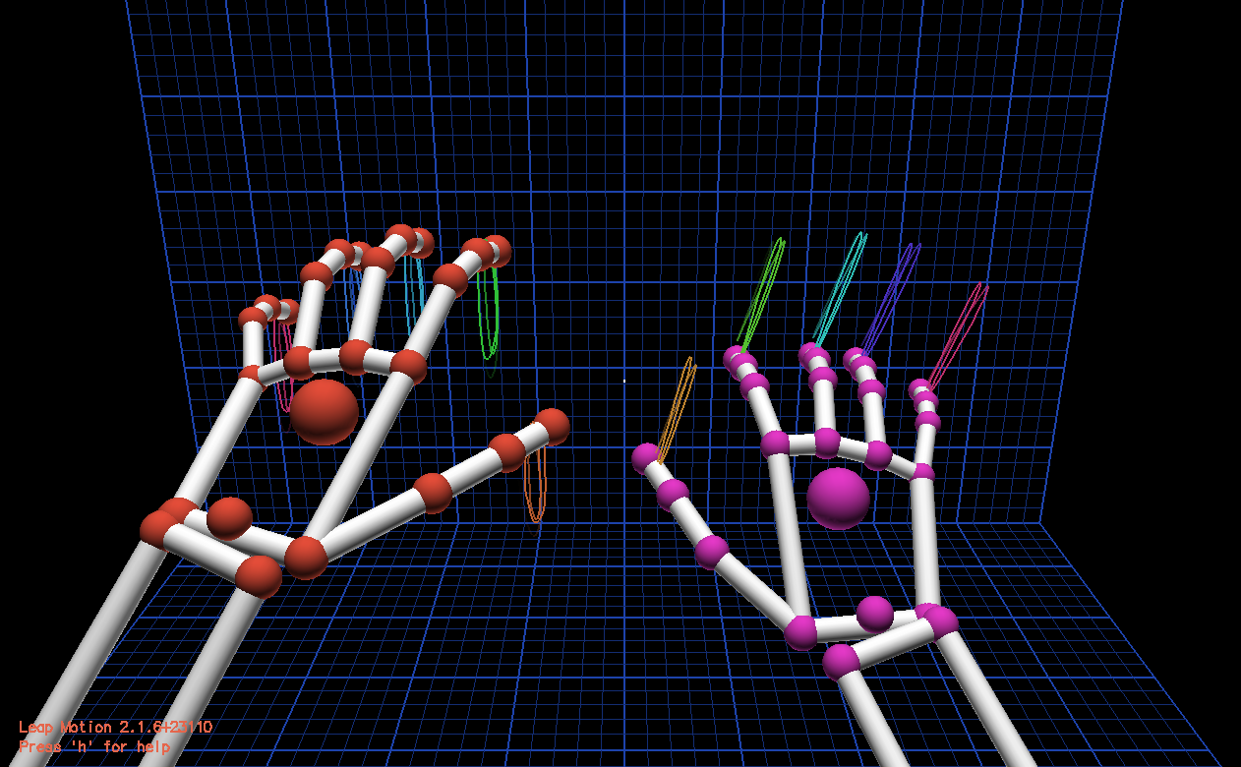

http://h10025.www1.hp.com/ewfrf-JAVA/Image/common/note.png

**NOTE:** For best performance of the Leap Motion sensor:

* Set up your Leap Motion device away from direct sunlight or other bright infrared (IR) sources.
* Pull back long sleeves and remove large jewellery or other items from your hands.
* Be sure the Leap Motion sensor is clean and free of scratches or debris.
* Keep hands parallel to the sensor and within the sensor range. Spread your fingers to improve sensor detection.